Type of indexes
B-Tree Indexes
B-trees, short for balanced trees, are the most common type of database index. A B-tree index is an ordered list of values divided into ranges. By associating a key with a row or range of rows, B-trees provide excellent retrieval performance for a wide range of queries, including exact match and range searches

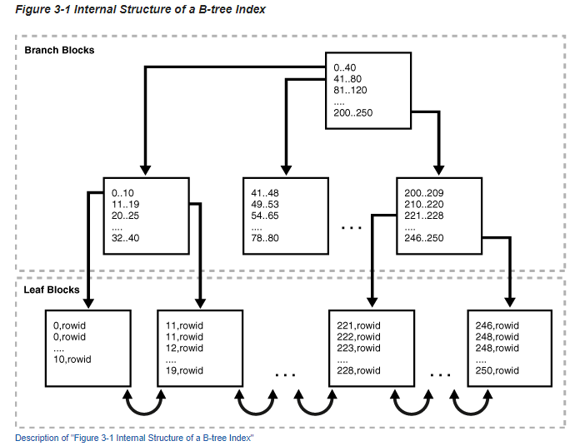

Bitmap Indexes
In a bitmap index, the database stores a bitmap for each index key. In a conventional B-tree index, one index entry points to a single row. In a bitmap index, each index key stores pointers to multiple rows. Bitmap indexes are primarily designed for data warehousing or environments in which queries reference many columns in an ad hoc fashion.
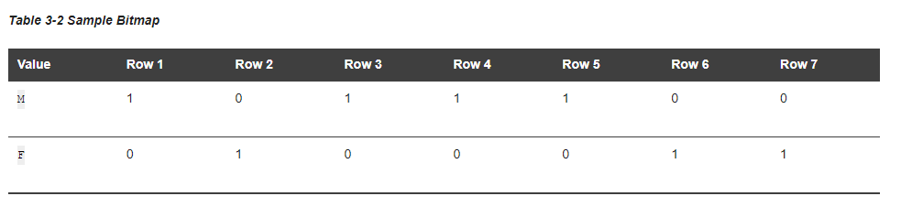

Function-Based Indexes
You can create indexes on functions and expressions that involve one or more columns in the table being indexed. A function-based index computes the value of a function or expression involving one or more columns and stores it in the index. A function-based index can be either a B-tree or a bitmap index

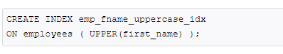

Domain Indexes
A domain index is an index designed for a specialized domain, such as spatial or image processing. Users can build a domain index of a given type after the designer creates the indextype. The behavior of domain indexes is specific to an industry, a business function, or some other special purpose; you must specify it during cartridge development.

Partitioned indexes
A partitioned index is made up of a set of index partitions, each of which contains the index entries for a single data partition. Each index partition contains references only to data in its corresponding data partition. Both system- and user-generated indexes can be partitioned.

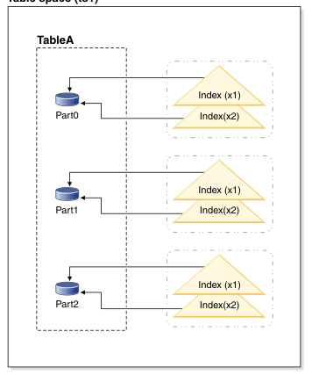

=>WE USE B_TREE INDEX BECAUSE WE NEED TO MAKE AN INDEX IN A SINGLE COULMN .

